[**Rival IQ**](https://www.rivaliq.com/) is a social media analytics tool that can help businesses track their success across a number of channels—YouTube included. With features like competitor analysis, basic social analytics, social listening, reporting and social media audits, Rival IQ is a great option for businesses with a widespread online presence. It can also be a huge help for agencies working with multiple clients.

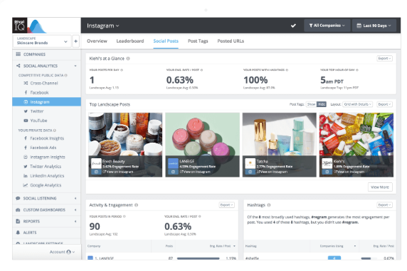

[**Iconosquare**](https://www.iconosquare.com/) started as a basic [**Instagram analytics tool**](https://sproutsocial.com/insights/instagram-analytics-tools/) years before the platform started offering its own built-in insights. At the time, this tool was one of the only ways to effectively monitor your Instagram efforts. However, as platforms adapt and change, analytics tools must do the same.

Now, Iconosquare is a robust social media analytics tool that lets users monitor 100+ different metrics across various social media platforms. Supported social media platforms include Instagram, Facebook, Twitter, LinkedIn and TikTok.

